30th September 2019

Dear Parents/Carers
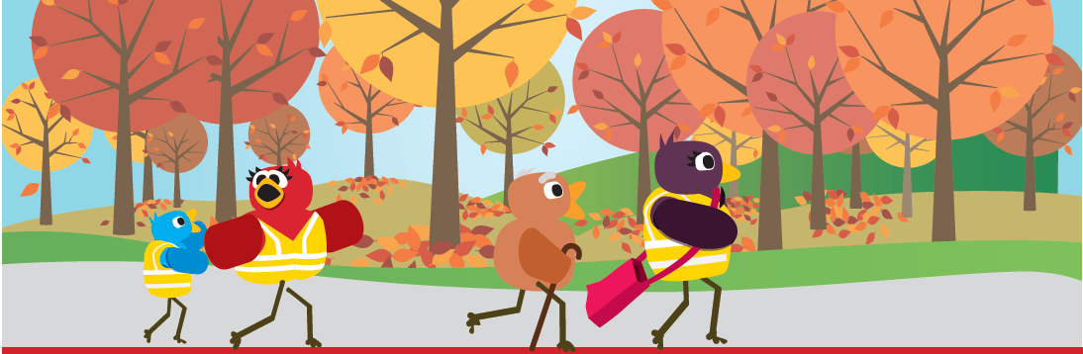
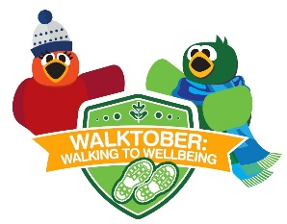
Walktober!

Walktober is back! This October we are encouraging all members of our school community – children, parents and staff to become more active by increasing the number of walks they take. Everybody leads busy lives, but can you fit in an extra walk, whether to enjoy some of our lovely Gosport scenery – Stokes Bay, Gilkicker, the creeks, the harbour or our many paths – or further afield in Hampshire and beyond?
This year there Walktober is linked with the NHSs Five Steps to Well-Being:

Connect
Encourage your friends and family to join you on a walk

Be active
Build walking into your routine with a lunchtime stroll, or why not take the bus or train to work and get off a stop earlier?

Keep learning
Enjoy a historical or educational walk, or why not explore a new park you haven't visited before?

Be mindful
Take time to be mindful and notice the world around you with a nature filled jaunt.

Give to others

Why not take a neighbour out for a cuppa and walk

The children will be bringing home challenge cards to record their walks. All members of the family can help complete the card! Go online and share your walks with www.myjourneyhampshire.com/ for a chance to win a prize.
Yours sincerely

Julie Millard
PE Leader

